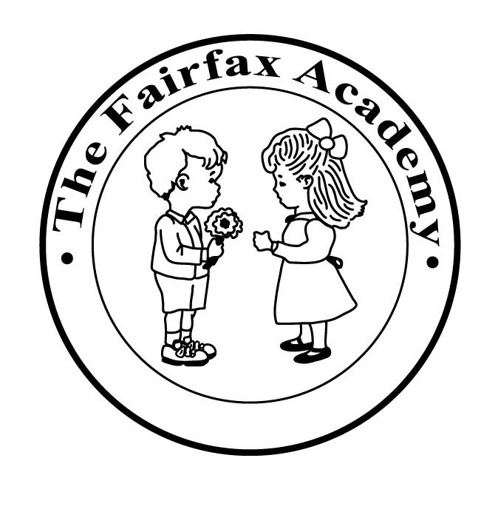**Fairfax Academy**

820 South Carlin Springs Road

Arlington, Virginia 22204

(703) 671-5555

Welcome to a new school year! We are excited to be celebrating over Forty-Seven years in business and are proud of our excellent reputation for both high quality childcare and academic excellence. We are pleased that you will be joining us and look forward to a rewarding school year. Please take time to review and make note of the information contained in this packet. **The yearly calendar contains vital information concerning school closings, special events and open houses.**

Academic classes begin on **September 3, 2024**. Our curriculum includes a series of outstanding, age-appropriate programs, which are designed to contribute to the social, emotional and mental growth of each child. Our core curriculum includes weekly classes in physical education, and art for all children.

**CURRENT DATA:** A new Current Data Sheet must be filled out each school year. It is a **State requirement** in case of an emergency that we know who to contact (Please let us know if any Phone Numbers change). Please make sure you have these filled out and returned by **September 3, 2024.**

Parents check out our website [www.thefairfaxacademy.com](http://www.thefairfaxacademy.com)

I would like to introduce the members of the administrative team. These people are vital to the operation of the school community and provide a wealth of information, care and guidance to teachers, students and parents.

Mrs. Katherine B. Webster – CEO

Mr. Brandon Dukstein – Center Director

Mrs. Ana Espinoza – Assistant Director

Ms. Courtney Flynn – Admissions Coordinator

Mrs. Anna Crutchfield – Administration

If you have any questions or concerns, please contact us via phone or by accessing our email address via our website [www.thefairfaxacademy.com](http://www.thefairfaxacademy.com).

Sincerely,

Katherine B. Webster, CEO